|  |
| --- |
| **VISVESVARAYA TECHNOLOGICAL UNIVERSITY**  JNANA SANGAMA, BELAGAVI – 590 018        **An Internship Project Report**  **on**  ***Bed Time Stories App***  Submitted in partial fulfilment of the requirements for the VIII Semester of degree of  **Bachelor of Engineering in Information Science and Engineering** of Visvesvaraya  Technological University, Belagavi    **By**    **Ila S Raj**  **1RN18IS053**  **Under the Guidance of**  **Mrs. Kusuma S**    **Associate Professor**  **Department of ISE**      **Department of Information Science & Engineering**  **RNS Institute of Technology**  **Dr. Vishnuvaradhan Road, Rajarajeshwari Nagar post,**  **Channasandra, Bengaluru-560098**  **2021-2022** |
| **RNS INSTITUTE OF TECHNOLOGY**  **Dr. Vishnuvaradhan Road, Rajarajeshwari Nagar post, Channasandra, Bengaluru - 560098**    **DEPARTMENT OF INFORMATION SCIENCE AND ENGINEERING**        **CERTIFICATE**  Certified that the Internship work entitled ***To Do List*** has been successfully completed by **Ila S Raj (1RN18IS053)** bonafide students of **RNS Institute of Technology, Bengaluru** in partial fulfillment of the requirements of 8th semester for the award of degree in Bachelor of Engineering **in Information Science and Engineering** of **Visvesvaraya Technological University, Belagavi** during academic year **2021-2022**. The internship report has been approved as it satisfies the academic requirements in respect of internship work for the said degree.        **Mr. Kusuma S Dr. Suresh L Dr. M K Venkatesha**  Internship Guide Professor and HoD Principal  Associate Professor Department of ISE RNSIT  Department of ISE RNSIT            **External Viva**    **Name of the Examiners Signature with Date**       1. **1. _**      1. **2. _** | |

# DECLARATION

I, **Ila S Raj [USN: 1RN18IS053]** student of VII Semester BE, in Information Science and Engineering, RNS Institute of Technology hereby declare that the Internship work entitled ***Bed Time Stories app*** has been carried out by us and submitted in partial fulfilment of the requirements for the *VII Semester degree of* ***Bachelor of Engineering in Information Science and Engineering*** *of Visvesvaraya Technological University, Belagavi* during academic year 20212022.

Place : Bengaluru **Ila S Raj**

Date : **(1RN18IS053)**

# ABSTRACT

A bedtime story is a traditional form of storytelling, where a story is told to a child at bedtime to prepare the child for sleep. The bedtime story has long been considered "a definite institution in many families".

Reading bedtime stories yields multiple benefits for parents and children alike. The fixed routine of a bedtime story before sleeping can improve the child's brain development, language mastery, and logical thinking skills.

Bedtime stories are also useful for teaching the child abstract virtues such as sympathy, selflessness, and self-control

# ACKNOWLEDGMENT

At the very onset I would like to place our gratefulness to all those people who helped me in making the Internship a successful one.

Coming up, this internship to be a success was not easy. Apart from the sheer effort, the enlightenment of the very experienced teachers also plays a paramount role because it is they who guided me in the right direction.

First, I would like to thank the **Management of RNS Institute of Technology** for providing such a healthy environment for the successful completion of internship work.

In this regard, we express sincere gratitude to our beloved Principal **Dr. M K Venkatesha,** for providing us all the facilities.

I am extremely grateful to our own and beloved Professor and Head of Department of Information science and Engineering, **Dr. Suresh L**, for having accepted to patronize me in the right direction with all her wisdom.

I place our heartfelt thanks to Mr. Kusuma S Associate Professor, Department of Information Science and Engineering for having guided internship and all the staff members of the department of Information Science and Engineering for always helping.

I thank Mr. Akshay D R, ENMAZ, for providing the opportunity to be a part of the

Internship program and having guided me to complete the same successfully.

I also thank our internship coordinator Dr. R Rajkumar , Associate Professor , Department of Information Science and Engineering. I would thank my friends for having supported me with all their strength and might. Last but not the least, I thank my parents for supporting and encouraging me throughout. I have made an honest effort in this assignment.

**Ila S Raj**

**1RN18IS053**

# 

# TABLE OF CONTENTS

**CERTIFICATE** ii

**DECLARATION** iii

**ABSTRACT** iv

**ACKNOWLEDGMENT** v

**TABLE OF CONTENTS** vi

**LIST OF FIGURESABBREVIATIONS** viii vii

1. **INTRODUCTION** 1
   1. Introduction To Flutter 1
   2. History 1
   3. Frame Work Architecture 2
2. **LITERATURE SURVEY** 3
   1. TaskDo 3
      1. Introduction 4
      2. Related Work 5
3. **ANALYSIS** 7
   1. Hardware and Software Requirements 7
   2. Tool/ Languages/ Platform 7
   3. Functional Requirements 8
4. **System Design** 9
   1. Home Page Widget Tree 9
   2. ToDo List page Widget Tree 10

* 1. Database Schema Design 11

1. **IMPLEMENTATION DETAILS** 12
   1. main.dart 12
   2. HomePage.dart 13
   3. taskPage.dart 17
   4. database_helper.dart 26
   5. widgets.dart 29
2. **TESTING** 34
   1. Introduction 34
   2. Levels Of Testing 34
      1. Unit Testing 34
      2. Integration Testing 35
      3. System Testing 35
      4. Validation Testing 35
      5. Output Testing 35
      6. User Validation Testing 35
3. **DISCUSSION OF RESULTS** 36
   1. Home Page 36
   2. Content page 37
   3. Configuration page 38
4. **CONCLUSION AND FUTURE WORK** 39
   1. Conclusion 39
   2. Future work 39
5. **REFERNECES** 40

**LIST OF FIGURES**

**Figure. No. Descriptions Page**

Figure. 4.1 Home Page Widget Tree 09

Figure. 4.2 To Do List Widget Tree 10

Figure. 4.3 Database Schema Design 11

Figure. 7.1 Home Page 36

Figure. 7.2 Display ToDo List 37

Figure 7.3 Creating a New List 38

**ABBREVIATIONS**

UI : User Interface

FK : Flutter Kick

IoT : Internet Of Things

FCL : Flutter Cycle Length

AOT : Ahead Of Time

SDK : Software Development Kit

**Chapter 1**

## INTRODUCTION

### 1.1 Introduction to Flutter

Flutter is Google’s Mobile SDK to build native iOS and Android, Desktop (Windows, Linux, macOS), Web apps from a single codebase. When building applications with Flutter everything towards Widgets – the blocks with which the flutter apps are built. They are structural elements that ship with a bunch of material design-specific functionalities and new widgets can be composed out of existing ones too. The process of composing widgets together is called composition. The User Interface of the app is composed of many simple widgets, each of them handling one particular job. That is the reason why Flutter developers tend to think of their flutter app as a tree of widgets.

### 1.2 History

Flutter launched as a project called Sky which at the beginning worked only on Android. Flutter’s goal is enabling developers to compile for every platform using its own graphic layer rendered by the Skia engine. Here’s a brief presentation of Flutter’s relatively short history.

Flutter is a free and open-source mobile UI framework created by Google and released in May 2017. In a few words, this allows you to create a native mobile application with only one code. It means that you can use one programming language and one codebase to create two different apps (IOS and Android).

The first version of Flutter was known by the codename "Sky" and ran on the Android operating system. It was unveiled at the 2015 Dart developer summit[6] with the stated intent of being able to render consistently at 120 frames per second.[7] During the keynote of Google Developer Days in Shanghai in September 2018, Google announced Flutter Release Preview 2, which is the last big release before Flutter 1.0. On December 4th of that year, Flutter 1.0 was released at the Flutter Live event, denoting the first "stable" version of the Framework. On December 11, 2019, Flutter 1.12 was released at the Flutter Interactive event.[8]

On May 6, 2020, the Dart software development kit (SDK) in version 2.8 and the Flutter in version 1.17.0 were released, where support was added to the Metal API,

improving performance on iOS devices (approximately 50%), new Material widgets, and new network tracking.

On March 3, 2021, Google released Flutter 2 during an online Flutter Engage event. This major update brought official support for web-based applications with new CanvasKit renderer and web specific widgets, early-access desktop application support for Windows, macOS, and Linux and improved Add-to-App APIs.[9] This release included sound nullsafety, which caused many breaking changes and issues with many external packages, but the Flutter team included instructions to mitigate these changes as well.

On September 8th, 2021, the Dart SDK in version 2.14 and Flutter version 2.5 were released by Google. The update brought improvements to the Android Full-Screen mode and the latest version of Google's Material Design called Material You. Dart received two new updates, the newest lint conditions have been standardized and preset as the default conditions as well Dart for Apple Silicon is now stable.

### 1.3 Framework-Architecture

The major components of Flutter include:

* Dart platform
* Flutter engine
* Foundation library
* Design-specific widgets
* Flutter Development Tools (DevTools)

#### Dart platform

Flutter apps are written in the Dart language and make use of many of the language's more advanced features.

On Windows, macOS, and Linux[11] Flutter runs in the Dart virtual machine, which features a just-in-time execution engine. While writing and debugging an app, Flutter uses Just In Time compilation, allowing for "hot reload", with which modifications to source files can be injected into a running application. Flutter extends this with support for stateful hot reload, where in most cases changes to source code are reflected immediately in the running app without requiring a restart or any loss of state.

For better performance, release versions of Flutter apps targeting Android and iOS are compiled with ahead-of-time (AOT) compilation.

#### Flutter engine

Flutter's engine, written primarily in C++, provides low-level rendering support using Google's Skia graphics library. Additionally, it interfaces with platform- specific SDKs such as those provided by Android and iOS.[10] The Flutter Engine is a portable runtime for hosting Flutter applications. It implements Flutter's core libraries, including animation and graphics, file and network I/O, accessibility support, plugin architecture, and a Dart runtime and compile toolchain. Most developers interact with Flutter via the Flutter Framework, which provides a reactive framework and a set of platform, layout, and foundation widgets.

#### Foundation library

The Foundation library, written in Dart, provides basic classes and functions that are used to construct applications using Flutter, such as APIs to communicate with the engine.

#### Design-specific widgets

The Flutter framework contains two sets of widgets that conform to specific design languages: Material Design widgets implement Google's design language of the same name, and Cupertino widgets implement Apple's iOS Human interface guidelines.

**Chapter 3**

## ANALYSIS

### 3.1 Hardware and Software Requirements

The Hardware requirements are very minimal and the program can be run on most of the machines.

|  |  |  |
| --- | --- | --- |
| Processor | : | Pentium 4 Processor |
| Processor Speed | : | 2.4 GHz |
| RAM | : | 2 GB |
| Storage Space | : | 40 GB |

The software requirements are very minimal and the program can be run on the machines with these requirements satisfied:

|  |  |  |
| --- | --- | --- |
| Editor | : | Visual Studio Code |
| Operating System | : | Windows/Mac OS |
| IDE | : | VS Code |
| Backend Tool | : | SQLite |

### 3.2 Tools/ Languages/ Platform

Various tool used in making this project is given below:

|  |  |  |
| --- | --- | --- |
| Editor/IDE | : | Visual Studio Code |
| Operating System | : | Windows/Mac OS |
| Languages | : | Dart, Swift, SQLite |
|  |  |  |

**3.3 Functional Requirements**

### Flutter

Flutter is Google’s Mobile SDK to build native iOS and Android apps from a single codebase. When building applications with Flutter everything towards Widgets – the blocks with which the flutter apps are built. The User Interface of the app is composed of many simple widgets, each of them handling one particular job. That is the reason why Flutter developers tend to think of their flutter app as a tree of widgets.

Compared to its contemporary technologies like React Native, Kotlin, and Java, Flutter is much better in regard to having a Single Codebase for Android and iOS, Reusable UI and Business Logic, high compatibility, performance, and productivity.

### Dart

Dart is an open-source general-purpose programming language developed by Google. It supports application development in both client and server-side. But it is widely used for the development of android apps, iOS apps, IoT(Internet of Things), and web applications using the Flutter Framework.

Syntactically, Dart bears a strong resemblance to Java, C, and JavaScript. It is a dynamic object-oriented language with closure and lexical scope. The Dart language was released in 2011 but came into popularity after 2015 with Dart 2.0.

### SQLite

SQLite is a self-contained, high-reliability, embedded, full-featured, public-domain, SQL database engine. It is the most used database engine in the world. It is an in-process library and its code is publicly available. It is free for use for any purpose, commercial or private. It is basically an embedded SQL database engine. The SQLite database file format is cross platform so that anyone can easily copy a database between 32-bit and 64- bit systems. Due to all these features, It is a popular choice as an Application File Format.

**Chapter 4**

## SYSTEM DESIGN

**4.1 Home page widget tree:**

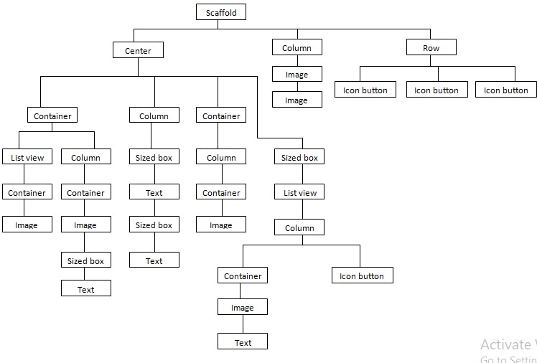

### Fig 4.1 HomePage Widget Tree

**4.2 Main page widget tree:**

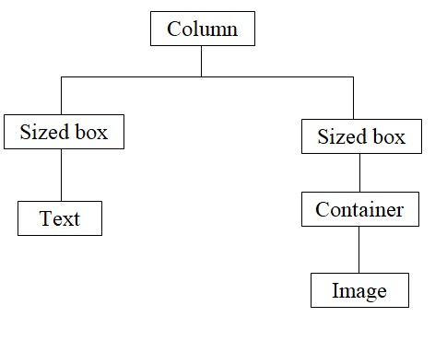

### Fig 4.2 Main page Widget Tree

**4.3 Configuration page widget tree:**

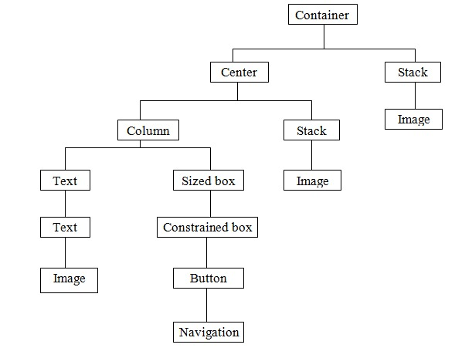

Fig 4.3 Configuration page widget tree

**Chapter 5**

## IMPLEMENTATION DETAILS

### 5.1 main.dart

|  |
| --- |
| import 'package:flutter/material.dart';  import 'package:flutter_svg/flutter_svg.dart';  import 'package:bedtime_stories_app/HomePage.dart';  void main() {    runApp(MaterialApp(      debugShowCheckedModeBanner: false,      home: GetStarted(),    ));  }  class GetStarted extends StatelessWidget {    // This widget is the root of your application.    @override    Widget build(BuildContext context) {      return Scaffold(        backgroundColor: const Color(0xFF03174C),        body: Container(          child: Stack(            children: [              SvgPicture.asset(                'assets/bg_wave.svg',                fit: BoxFit.cover,                alignment: AlignmentDirectional.topStart,              ),              Center(                child: Stack(                  children: [                    SvgPicture.asset(                      'assets/bg_clouds.svg',                      fit: BoxFit.fitWidth,                    ),                    Column(                      children: [                        SizedBox(                          height: 120,                        ),                        Text(                          "Welcome to Bedtime stories",                          style: TextStyle(                              fontSize: 30,                              fontWeight: FontWeight.bold,                              color: Colors.white),                        ),                        SizedBox(                          height: 10,                        ),                        Padding(                          padding: const EdgeInsets.all(20.0),                          child: Text(                            "Explore the new king of sleep, it uses visualisation to create perfect conditions for refreshing sleep",                            style: TextStyle(                              fontSize: 15,                              color: Colors.white,                            ),                            textAlign: TextAlign.center,                          ),                        ),                        SizedBox(                          height: 50,                        ),                        Stack(children: [                          Align(                            alignment: Alignment.topRight,                            child: SvgPicture.asset(                              'assets/bg_birds.svg',                              fit: BoxFit.fill,                            ),                          ),                        ]),                        SizedBox(                          height: 60,                        ),                        Padding(                          padding: const EdgeInsets.all(20.0),                          child: ConstrainedBox(                            constraints:                                BoxConstraints.tightFor(width: 400, height: 50),                            child: ElevatedButton(                              child: Text(                                "Get Started".toUpperCase(),                                style: TextStyle(fontSize: 14),                              ),                              style: ButtonStyle(                                foregroundColor: MaterialStateProperty.all<Color>(                                    Colors.white),                                backgroundColor: MaterialStateProperty.all<Color>(                                    Color(0xFF8E97FD)),                                shape: MaterialStateProperty.all<                                        RoundedRectangleBorder>(                                    RoundedRectangleBorder(                                        borderRadius: BorderRadius.circular(18.0),                                        side: BorderSide(                                            color: Colors.deepPurpleAccent))),                              ),                              onPressed: () {                                Navigator.push(                                  context,                                  MaterialPageRoute(                                      builder: (context) => HomePage()),                                );                              },                            ),                          ),                        ),                      ],                    ),                  ],                ),              ),            ],          ),        ),      );    }  } |

**5.2 homepage.dart**

import 'package:flutter/cupertino.dart';

import 'package:flutter/material.dart';

import 'package:flutter/painting.dart';

import 'package:flutter_svg/flutter_svg.dart';

import 'package:bedtime_stories_app/config/configurations.dart';

import 'package:bedtime_stories_app/content.dart';

class HomePage extends StatefulWidget {

  @override

  _HomePageState createState() => _HomePageState();

}

class _HomePageState extends State<HomePage> {

  @override

  Widget build(BuildContext context) {

    return Scaffold(

      backgroundColor: const Color(0xFF03174C),

      body: SingleChildScrollView(

        child: Stack(

          children: [

            SvgPicture.asset(

              'assets/bg_home_border.svg',

              width: MediaQuery.of(context).size.width,

              height: MediaQuery.of(context).size.height,

              alignment: AlignmentDirectional.topStart,

            ),

            SvgPicture.asset(

              'assets/bg_moon_home.svg',

              width: MediaQuery.of(context).size.width,

              height: MediaQuery.of(context).size.height,

              alignment: AlignmentDirectional.topStart,

            ),

            SafeArea(

              child: Center(

                child: Column(

                  children: [

                    SizedBox(

                      height: 30,

                    ),

                    Text(

                      "Sleep Stories",

                      style: TextStyle(

                          fontSize: 28,

                          fontWeight: FontWeight.bold,

                          color: Colors.white),

                      textAlign: TextAlign.center,

                    ),

                    SizedBox(

                      height: 30,

                    ),

                    Text(

                      "Soothing bedtime stories to help you fall \n into a deep and natural sleep",

                      style: TextStyle(

                          fontSize: 15,

                          fontWeight: FontWeight.normal,

                          color: Colors.white),

                      textAlign: TextAlign.center,

                    ),

                    SizedBox(

                      height: 40,

                    ),

                    Container(

                      height: 90,

                      child: ListView.builder(

                          scrollDirection: Axis.horizontal,

                          itemCount: categories.length,

                          itemBuilder: (context, index) {

                            return Container(

                              child: Column(

                                children: [

                                  Container(

                                    padding: EdgeInsets.all(10),

                                    margin: EdgeInsets.only(left: 20),

                                    decoration: BoxDecoration(

                                        color: primaryBlue,

                                        borderRadius:

                                            BorderRadius.circular(10)),

                                    child: Image.asset(

                                      categories[index]['iconPath'],

                                      height: 40,

                                      width: 40,

                                    ),

                                  ),

                                  SizedBox(

                                    height: 10,

                                  ),

                                  Text(

                                    categories[index]['name'],

                                    style: TextStyle(color: Colors.white),

                                    textAlign: TextAlign.center,

                                  )

                                ],

                              ),

                            );

                          }),

                    ),

                    Container(

                      padding: EdgeInsets.all(20.0),

                      child: Column(

                        children: [

                          Container(

                            width: double.infinity,

                            height: 250,

                            decoration: BoxDecoration(

                                borderRadius: BorderRadius.circular(20),

                                image: DecorationImage(

                                    image: AssetImage('assets/bg_moun.png'),

                                    fit: BoxFit.fill)),

                          ),

                        ],

                      ),

                    ),

                    SizedBox(

                      height: 130,

                      child: ListView.builder(

                          scrollDirection: Axis.horizontal,

                          itemCount: listItems.length,

                          itemBuilder: (context, index) {

                            return Container(

                              child: Column(

                                children: [

                                  InkWell(

                                    onTap: () {

                                      Navigator.push(

                                          context,

                                          MaterialPageRoute(

                                              builder: (context) =>

                                                  ContentScreen(index: index)));

                                    },

                                    child: Container(

                                      margin: EdgeInsets.only(left: 20),

                                      decoration: BoxDecoration(

                                          color: primaryBlue,

                                          borderRadius:

                                              BorderRadius.circular(20)),

                                      child: Image.asset(

                                        listItems[index]['iconPath'],

                                        height: 100,

                                        width: 140,

                                        fit: BoxFit.fill,

                                      ),

                                    ),

                                  ),

                                  SizedBox(

                                    height: 10,

                                  ),

                                  Text(

                                    listItems[index]['name'],

                                    style: TextStyle(color: Colors.white),

                                    textAlign: TextAlign.center,

                                  )

                                ],

                              ),

                            );

                          }),

                    ),

                  ],

                ),

              ),

            ),

          ],

        ),

      ),

      bottomNavigationBar: BottomNavigationBar(

        currentIndex: 0,

        backgroundColor: Color(0xFF03174C),

        // this will be set when a new tab is tapped

        type: BottomNavigationBarType.fixed,

        items: [

          BottomNavigationBarItem(

            icon: new Icon(Icons.home),

            label: 'Home',

          ),

          BottomNavigationBarItem(

            icon: new Icon(Icons.nights_stay_outlined),

            label: 'Sleep',

          ),

          BottomNavigationBarItem(

            icon: new Icon(Icons.nightlife),

            label: 'Meditate',

          ),

          BottomNavigationBarItem(

            icon: new Icon(Icons.music_note),

            label: 'Music',

          ),

          BottomNavigationBarItem(icon: Icon(Icons.person), label: 'Profile')

        ],

      ),

    );

  }

}

### 5.3 content.dart

import 'package:flutter/material.dart';

import 'package:bedtime_stories_app/config/configurations.dart';

class ContentScreen extends StatelessWidget {

  var index;

  ContentScreen({this.index});

  @override

  Widget build(BuildContext context) {

    return Scaffold(

      backgroundColor: const Color(0xFF03174C),

      appBar: AppBar(

        backgroundColor: const Color(0xFF03174F),

        title: Text(listItems[index]['name']),

      ),

      body: Content(index: index),

    );

  }

}

class Content extends StatelessWidget {

  var index;

  Content({this.index});

  @override

  Widget build(BuildContext context) {

    return SingleChildScrollView(

      child: Column(

        children: [

          SizedBox(

            height: 30,

          ),

          Container(

            alignment: Alignment.center,

            child: Image.asset(

              listItems[index]['iconPath'],

            ),

          ),

          SizedBox(

            height: 30,

          ),

          Text(

            contentList[index],

            style: TextStyle(color: Colors.white, fontSize: 17),

            textAlign: TextAlign.start,

          )

        ],

      ),

    );

  }

}

### 5.4 configurations.dart

|  |
| --- |
| import 'package:flutter/cupertino.dart';  import 'package:flutter/material.dart';  Color primaryBlue = Color(0xFF586894);  List<BoxShadow> shadowList = [    BoxShadow(color: Color(0xFF586894), blurRadius: 30, offset: Offset(0, 10))  ];  List<Map> categories = [    {'name': 'All', 'iconPath': 'assets/icons/all_icon.png'},    {'name': 'My', 'iconPath': 'assets/icons/fav_icon.png'},    {'name': 'Anxious', 'iconPath': 'assets/icons/anxious_icon.png'},    {'name': 'Kids', 'iconPath': 'assets/icons/kid_icon.png'},    {'name': 'Sleep', 'iconPath': 'assets/icons/moon_icon.png'},  ];  List<Map> listItems = [    {      'name': 'Night Island',      'time': '45 MIN . Sleep Music',      'iconPath': 'assets/icons/item_1.png',    },    {      'name': 'Sweet Sleep',      'time': '32 MIN . Sleep Music',      'iconPath': 'assets/icons/item_2.png',    },    {      'name': 'Blessing Eve',      'time': '25 MIN . Sleep Music',      'iconPath': 'assets/icons/item_3.png',    },    {      'name': 'Good',      'time': '28 MIN . Sleep Music',      'iconPath': 'assets/icons/item_4.png',    },    {      'name': 'Melody Night',      'time': '45 MIN . Sleep Music',      'iconPath': 'assets/icons/item_1.png',    },    {      'name': 'Good Sleep',      'time': '32 MIN . Sleep Music',      'iconPath': 'assets/icons/item_2.png',    },    {      'name': 'Eve Day',      'time': '25 MIN . Sleep Music',      'iconPath': 'assets/icons/item_3.png',    },    {      'name': 'Sun Noon',      'time': '28 MIN . Sleep Music',      'iconPath': 'assets/icons/item_4.png',    },  ];  List contentList = [    "It was one stormy night as Mina lay on the beach. She was a solo navigator sailor that was in a race around the world in her boat which was nowhere to be seen. She lay on the beach as they day went by. Suddenly, she woke up. “I am alive” she whispered to herself. A dark shadow glanced upon her. Then it disappeared. She felt like she was being watched. Was she on a deserted island or an inhabited land?I looked around slowly. I found a fish in a nearby rock pool that must have been carried through the hard night. I caught it and saved it for later. Suddenly I hear this strange noise and I am paralysed for 10 seconds. All was black! I could not see anything. Then it all stopped. I felt like I was dying. I needed to get some food into me before I feel crazy.I found a good place to make a fire. I needed a flammable resource and some wood to cook the fish. I found and old shipwreck and took some wood from that. I also found some lichen on a tree. I used them to make a fire. I ate the fish and it was lovely. I felt much better so I decided to explore the rest of the island.I walked up a path which would take me to the plateau. I suddenly realised that there was a strange mechanism on the side of the cliff. It was old and rusty. I was not quite sure what it was used for so I thought that this island was inhabited after all…I walked onto the plateau. It was so quiet and peaceful. There was some smoke coming from over the bush. Could it be an inhabited building? I walked over there. No! It was just steam coming from the hot spring. I could use it to cook something. I turn around. There is a snake hissing at me. I slowly picked up a forked branch and pinned it to the ground. I walked over to a broken stair case. I had to fix it somehow.I hear a cry from an abandoned cottage. I run over there. There is an injured monkey. I decide to give it a name. I called him Jep. I cleaned his wound and gave him some grapes from a grape vine. We found an old abandoned wind mill. The sails had been torn off and we needed to repair it. I took a bit of my shirt off and replaced the old sales. Eventually we got the windmill working. There were no trees around the windmill area and there were hardly any trees around the plateau so anyone could see the mill spin from miles away. Suddenly I thought that if I could keep it spinning for ages then someone might recognise it. I heard a noise. It was the rescue team! They had found me. They took me home.",    "This tale is from Argentina and tells the story of a young girl, the friendship she develops with a wild puma, and how kindness is repaid.Once there was a girl named Callista. Her father was a soldier, and after the country in which she was born, Spain, invaded South America, she moved to Argentina with her family.The people who lived in Argentina were angry the Spanish had taken over their land, so they surrounded the camp in which the Spanish families were living, hoping to make them leave.Callista was told not to leave the camp, but she was hungry. So, one day, she snuck out to find food.As she explored the jungle, she came across a cave where a mother puma had just given birth. Callista helped the mother puma clean the cubs and found food for her to eat.One day the native people found Callista, and she was scared. However, they did not harm her and instead took her back to their village, gave her food, and looked after her. Callista felt loved and at home and lived there a long while.Then, the Spanish soldiers attacked the village, found Callista, and took her back to the camp. Her father was very angry with her and sent soldiers to tie her to a tree in the jungle as punishment. She was there for days.The village people were scared she might die, but they were also scared of the Spanish soldiers. After three days, they went to try to rescue Callista but feared she would be dead. However, when they got to the trees, Callista was fine.The puma Callista cared for had come back to look after her.The villagers untied Callista and took her home with them, where she lived a long and happy life.",    "There was once an emperor who didnot care about ruling his land. Instead, all he cared about was living in his palace, having the finest food and drink, owning the most expensive things, and most of all, wearing the most beautiful clothes.One day some crooks came to the land. They told the emperor they had the finest cloth in the world, but it was magical. Only the smartest, most brilliant, most influential people could see it, and anyone who was not brilliant, intelligent, or important could see nothing.When the emperor was shown the cloth, he could see nothing at all, and he was scared.“If people find out I am not clever, or smart, or important, they will choose another emperor,” he thought. “Then, I will not be the most important person in the land, and the finest things will not surround me.”So the emperor told the crooks that yes, it was the finest cloth he had ever seen and asked them to make an outfit for his grand parade.On the day of the parade, everyone in the kingdom came to see the emperor. They had all heard about the magical cloth and wanted to see it for themselves.The giant parade began, and the emperor walked down the great National Mall. Nobody could see the magical clothes, but everyone was too afraid to speak up.A child then pointed at the emperor and asked, “Why is not he wearing any clothes?”This made other people brave enough to speak up, and soon, almost the entire kingdom was talking about the silly emperor. He was so worried about beautiful clothes, expensive things, and what people thought, he walked down the street naked rather than telling the truth.",    "You Need A Lion Whisker This fairy tale from Ethiopia tells the story of a woman who learns there are no shortcuts and that patience, perseverance, and hard work are essentialLeeya married a man who already had a son. She tried to be friends with the boy, but nothing she did worked. So Leeya went to see the medicine man in the mountains.“Please help me,” Leeya said. “I want the boy to be happy and to be friends with him. I have tried for an entire week, but nothing works.”“I can help, but first, I need you to pluck a whisker from a living lion and bring it to me,” he said.Leeya was afraid, but she wanted to be friends, so she went to where the lions lived.Every day for a month, Leeya would put out a bowl of meat and watch from behind a rock when the lion came to feed.The next month she did the same thing but knelt up, so her head was showing. The next month she stood taller so the lion could see her from the waist up, and the following month she stood beside the rock.For the next six months, she inched closer to the lion. In the tenth month, she stood next to him while he ate. In the eleventh, she held the bowl, and in the twelfth month, she would place her hand on the lion face.Finally, she was brave enough to pluck a whisker from the lion, and she took it to the medicine man. The medicine man accepted the whisker from her and threw it into the fire.“Why did you do that?” asked Leeya. “I worked hard for a full year to get that whisker.”“You worked hard,” said the medicine man. “You were patient, gave the lion what it needed, and gained its trust. Is it any harder to do the same for a young boy who misses his mother? ”Then Leeya understood. There were no shortcuts, but patience, love, understanding, and perseverance would get her where she wanted to be",    "Swapping Places This ancient tale is as relevant today as it was when it was first told. Everybody's job may seem easy until you have to do it yourself. Long ago, there was a family. The man went out every day to work on the farm, and the woman stayed in the house, working to look after the children and the home. One day the farmer came home and complained the house was a mess, the baby was crying, there was no butter, no bread, and his dinner was not ready. “What do you do all day?” he asked his wife angrily. “I could do a better job in one day than you do all week.” “Okay, then,” said his wife, “Tomorrow I will work on the farm, and you will look after the home”. And that is what they did .The woman went out early to work in the field, and the man began his day by feeding the chickens and putting milk in the churn to make butter .But the baby started crying, so he went to pick him up. While the man was shushing the baby, their toddler ran into the kitchen, knocked over the churn, and milk spilled everywhere. The man started to clean up the mess but realized he hadn't given the children their breakfast. He began to make breakfast, but he'd forgotten to close the door when he fed the chickens, and now they were in the house, leaving feathers and poop everywhere. And so it went on, all day. Every time he tried to do something, the farmer found other things went wrong. When the woman returned from the fields, she found the house covered in feathers and chicken poop. The children were hungry and dirty and had run through the milk leaving a sticky, smelly trail. She found her husband sitting on the bed with a crying baby. “I am sorry, dear wife,” he said, “I cannot believe all of the things you have to juggle while you work hard at home every day. I will never complain again.”And he didn't. Not only that, on the days he came home to no food, he would cook supper for the family, help with the children, and churn the butter for the next day.",    "Four pairs of children's shoes were lined up on our kitchen countertop, ready for a good shine before church in the morning. It was near midnight on Christmas Eve 1968, and everyone else in the house was asleep. I had the TV on low in the living room. The astronauts manning the Apollo 8 spacecraft kept me company, the footage from the mission a comforting hum in the background. As I worked the polish into my daughter's little saddle shoe, my mind kept wandering to her upcoming appointment at New York Presbyterian Hospital. Lauren was four years old. Outwardly, nothing was wrong with her—she was a happy, healthy little girl. But she hardly said a word, even though her hearing tests appeared normal. Two years of seeking help locally failed to offer any answers. Doctors and therapists seemed to chalk her silence up to her being the youngest of four, with the older kids doing the talking for her. Mother's intuition told me it was more than that. I'd finally gotten an appointment with a specialist at New York Presbyterian, an audiologist who ranked high in her field. I could hardly wait for our appointment a week into the new year.And if we get a diagnosis, then what?I thought, polishing around the toe of Lauren's shoe. If it wasn't Lauren's hearing, was it something worse?Thoughts like that aren't helping anyone, I told myself.Just keep polishing.To do that, I needed more shoe polish. That's when I heard… church bells.The TV broadcast had cut to the Midnight Mass at St. Patrick's Cathedral in New York City. As a practicing Catholic, I'd been taught to kneel and tap my chest for the coming of Jesus Christ.No one's here to see me,I thought, not particularly wanting to stop my work. But tradition won out. I put down the polish, barely dropped to one knee, quickly tapped my chest and got ready to pop back up.Instead, I froze. The tap to my chest seemed to reverberate. I felt a tap in return—a deep, barely perceptible feather's touch, right where I imagined my soul to be. An all-powerful, almighty wave of love overtook me. It flooded the house like a tsunami. Love flowed in from the window, over the counter, rose from the floor and rained down from the ceiling.I shut my eyes, both knees on the linoleum floor now, my head bowed. I didn't dare move as the love swept through the house, surrounding me—filling me. I felt gloriously perfect in God's eyes, even with all my glaring, human faults.The divine love receded as quickly as it had come. I didn't want it to leave. I wanted to go with it! But it was gone, and I was left kneeling in the kitchen, feeling oddly empty. Whatever had just happened was a miracle.But why me?I thought, looking around in a daze.Lauren.My mind jumped to Lauren. Something must be seriously wrong. And God was bracing me to face it.A week after New Year's, Lauren and I went to her appointment. The audiologist diagnosed Lauren in minutes. “I've been doing this for 20 years,” she said. “Your daughter's severely hard of hearing. I can tell by talking to her.” Tests confirmed the doctor was correct, and she arranged follow-up treatment, including hearing aids, to begin the very next week at Lenox Hill Speech and Hearing Center.“With words come ideas,” the lanky doctor at Lenox Hill told us when we got there. “That means this is an emergency at your daughter's age. If she doesn't learn to speak now, her abilities will be damaged forever.” Lauren needed therapy four days a week, with homework every night, including weekends.Lauren's progress was impressive, and she was never truly discouraged. As she got older, she faced many challenges in public schools geared toward hearing children. Whenever I worried whether she could meet those challenges, I'd think of that tidal wave of love I'd felt, God's love. Lauren didn't know about my Christmas Eve blessing. I wasn't sure she'd understand if I told her. And I didn't want her to think she'd caused me such pain that I'd needed divine intervention. But the memory of it sustained me all through her growing-up years.It wasn't until Lauren was in her thirties—married, with children of her own—that I finally decided to tell her about it. There was nothing special about the day I made the decision. It just seemed like it was time I shared my experience.I went over to her house one Saturday afternoon in August. As we leaned against her kitchen countertop, I carefully described what I'd felt that Christmas Eve night. She didn't stop me once to ask a question. Did she not believe me?“I remember,” Lauren said when I finished. “I watched the whole thing.”But she'd been in bed upstairs…“I couldn't sleep,” she said, “so I crept downstairs. You were in the kitchen. The shoes were all lined up on the countertop. I peeked in and saw you on your knees. The bells were ringing. An angelic light filled the house. I knew God was with us.”“But you were so young. How did you know what you were seeing?”Lauren looked at me with perfect confidence. “I just did.”Finally I knew the truth. God had come to both of us that Christmas Eve night. And he and his angels had been watching over us ever since.",    "One day two children were playing in a stream. When they got out, they were chilly, but the girl saw a soft, mossy area in the sun.“Let's go and sit there,” she said, “It will be warm in the sun.”The children laid on the moss and soon fell asleep. As the day went on, the rock inched upwards to keep them close to the sun and warm. The children were so comfortable they stayed asleep.At dinner time, the children's family searched everywhere but could not find them.Then coyote sniffed the ground, followed the childrens trail, and said, “They must be on top of this new rock.”Antelope was the best jumper, and the family asked him to get the children, but he could only reach a short way up the rock.Grizzly bear was the best climber, so they asked her to get the children, but she could only reach a little higher than antelope.All of the animals tried — jackrabbit, raccoon, even mountain lion, but none could reach the children.“Let me try,” said the inchworm, and all of the animals laughed.“You are too small,” they said. “How could you possibly do what we couldn't?”But the children's family asked him to try.Slowly, slowly, the inchworm passed the points the other animals had reached. Finally, he got to the top and woke the children by crawling on their faces and led them down the mountain.That day, the Miwok named the rock Tutokanula in honor of the inchworm, the tiny creature who achieved great things",    "The Reward is a cautionary tale from India and warns against the dangers of being greedy.There once was an emperor named Akbar. He went hunting in the woods, but when it started to get dark, he became lost. A young boy, Mahesh, heard the emperor calling for help, went into the jungle, and led him back to the palace.As a reward, the emperor took a ring from his finger and gave it to Mahesh.“Bring this ring back to the palace in the morning, show it to the guards, and tell them to let you in,” said the emperor, “Then I can reward you for your kindness.”The next day Mahesh came back to the palace, showed the ring to the guard, and asked to see the emperor. However, the guard was a greedy man and told Mahesh, “I will only let you in if you give me half of your reward.”Mahesh agreed and went to see the emperor.“I would like 50 lashes as my reward,” said Mahesh.The emperor tried to talk him out of it, but Maresh insisted. After the 25th lash, Mahesh stopped the emperor and explained about the guard.The emperor was very angry with the guard. He went out and gave the guard the remaining 25 lashes and fired him on the spot.Then the emperor asked Maresh again what he would like as a reward.“I promised the guard half of everything,” Maresh said, “So I do not want any further reward.”So, instead, the emperor gave Mahesh's family a new home and all they needed to enjoy a happy life."  ]; |

|  |
| --- |
| class DatabaseHelper {  Future<Database> database() async { return openDatabase( join(await getDatabasesPath(), 'todo.db'), onCreate: (db, version) async {  await db.execute("CREATE TABLE tasks(id INTEGER PRIMARY KEY, title  TEXT, description TEXT)");  await db.execute("CREATE TABLE todo(id INTEGER PRIMARY KEY, taskId INTEGER, title TEXT, isDone INTEGER)");  return db;  }, version: 1,  );  }  Future<int> insertTask(Task task) async { int taskId = 0;  Database _db = await database();  await _db.insert('tasks', task.toMap(), conflictAlgorithm: ConflictAlgorithm.replace).then((value) {  taskId = value;  }); return taskId;  }  Future<void> updateTaskTitle(int id, String title) async {  Database _db = await database(); |
| await _db.rawUpdate("UPDATE tasks SET title = '$title' WHERE id = '$id'");  }  Future<void> updateTaskDescription(int id, String description) async { Database _db = await database();  await _db.rawUpdate("UPDATE tasks SET description = '$description' WHERE id = '$id'");  }  Future<void> insertTodo(Todo todo) async { Database _db = await database();  await _db.insert('todo', todo.toMap(), conflictAlgorithm: ConflictAlgorithm.replace);  }  Future<List<Task>> getTasks() async {  Database _db = await database();  List<Map<String, dynamic>> taskMap = await _db.query('tasks'); return List.generate(taskMap.length, (index) {  return Task(id: taskMap[index]['id'], title:  taskMap[index]['title'], description: taskMap[index]['description']); });  }  Future<List<Todo>> getTodo(int taskId) async {  Database _db = await database();  List<Map<String, dynamic>> todoMap = await _db.rawQuery("SELECT * FROM todo WHERE taskId = $taskId"); return List.generate(todoMap.length, (index) { |

|  |
| --- |
| return Todo(id: todoMap[index]['id'], title:  todoMap[index]['title'], taskId: todoMap[index]['taskId'], isDone:  todoMap[index]['isDone']);    });    }        Future<void> updateTodoDone(int id, int isDone) async { Database _db = await database();  await _db.rawUpdate("UPDATE todo SET isDone = '$isDone' WHERE id = '$id'");    }        Future<void> deleteTask(int id) async { Database _db = await database(); await _db.rawDelete("DELETE FROM tasks WHERE id = '$id'"); await _db.rawDelete("DELETE FROM todo WHERE taskId = '$id'");  }        } |

### 5.5 widgets.dart

|  |
| --- |
| import 'package:flutter/material.dart';        class TaskCardWidget extends StatelessWidget { final String title;  final String desc;        TaskCardWidget({this.title, this.desc}); |

|  |
| --- |
| @override  Widget build(BuildContext context) { return Container( width: double.infinity, padding: EdgeInsets.symmetric( vertical: 32.0, horizontal: 24.0,  ), margin: EdgeInsets.only( bottom: 20.0,  ), decoration: BoxDecoration( color: Colors.white, borderRadius: BorderRadius.circular(20.0),  ), child: Column( crossAxisAlignment: CrossAxisAlignment.start, children: [  Text( title ?? "(Unnamed Task)", style: TextStyle( color: Color(0xFF211551), fontSize: 22.0, fontWeight: FontWeight.bold,  ),  ),  Padding( padding: EdgeInsets.only( top: 10.0, |
| ), child: Text( desc ?? "No Description Added", style: TextStyle( fontSize: 16.0, color: Color(0xFF86829D), height: 1.5,  ),  ),  )  ],  ),  );  }  }  class TodoWidget extends StatelessWidget { final String text; final bool isDone;  TodoWidget({this.text, @required this.isDone});  @override  Widget build(BuildContext context) { return Container( padding: EdgeInsets.symmetric( horizontal: 24.0, vertical: 8.0,  ), |
| child: Row( children: [  Container( width: 20.0, height: 20.0, margin: EdgeInsets.only( right: 12.0,  ), decoration: BoxDecoration( color: isDone ? Color(0xFF7349FE) : Colors.transparent, borderRadius: BorderRadius.circular(6.0), border: isDone ? null : Border.all( color: Color(0xFF86829D), width: 1.5  ) ), child: Image( image: AssetImage('assets/images/check_icon.png'),  ),  ),  Flexible( child: Text( text ?? "(Unnamed Todo)", style: TextStyle( color: isDone ? Color(0xFF211551) : Color(0xFF86829D), fontSize: 16.0, fontWeight: isDone ? FontWeight.bold : FontWeight.w500,  ),  ), |

|  |
| --- |
| ),    ],    ),    );    }    }        class NoGlowBehaviour extends ScrollBehavior {  @override  Widget buildViewportChrome(    BuildContext context, Widget child, AxisDirection axisDirection) { return child;  } |

**Chapter 6**

## TESTING

### 6.1 Introduction

Testing is a process of executing a program with the interest of finding an error.

A good test is one that has high probability of finding the yet undiscovered error. Testing should systematically uncover different classes of errors in a minimum amount of time with a minimum number of efforts .Two classes of inputs are provided provided to test the process

1. A software configuration that includes a software requirement specification, a design specification and source code.
2. A software configuration that includes a test plan and procedure, any testing tool and test cases and their expected results.

### 6.2 Levels of Testing

#### 6.2.1 Unit Testing

Unit testing is a level of software testing where individual units/ components of a softwareare tested. The purpose is to validate that each unit of the software performs as designed. A unit is the smallest testable part of any software. It usually has one or a few inputs and usually a single output.

Unit testing is commonly automated, but may still be performed manually. The objective in unit testing is to isolate a unit and validate its correctness. A manual approach to unit testing may employ a step-by-step instructional document. The unit testing is the process of testing the part of the program to verify whether the program is working corrector not. In this part the main intention is to check the each and every input which we are inserting to our file. Here the validation concepts are used to check whether the program istaking the inputs in the correct format or not.

Unit testing may reduce uncertainty in the units themselves and can be used in a bottom-up testing style approach. By testing the parts of a program first and then testing the sum of its parts, integration testing becomes much easier. Unit test cases embody characteristics that are critical to the success of the unit.

##### 

#### 6.2.2 Integration Testing

Integration testing is also taken as integration and testing this is the major testing process where the units are combined and tested. Its main objective is to verify whether the major parts of the program is working fine or not. This testing can be done by choosing the optionsin the program and by giving suitable inputs.

#### 6.2.3 System Testing

System testing is defined as testing of a complete and fully integrated software product. This testing falls in black-box testing wherein knowledge of the inner design of the code isnot a pre-requisite and is done by the testing team. System testing is done after integrationtesting is complete. System testing should test functional and non-functional requirementsof the software.

#### 6.2.4 Validation Testing

In this, requirements established as part of software requirements analysis are validated against the software that has been constructed. Validation testing provides final assurance that software meets all functional, behavioral and performance requirements. Validation can be defined in many ways but a simple definition is that validation succeeds when software Function in a manner that can be reasonably by the customer.

1. Validation test criteria
2. Configuration review
3. Alpha and Beta testing (conducted by end user)

#### 6.2.5 Output Testing

After preparing test data, the system under study is tested using the test data. While testing the system using test data, errors are again uncovered and corrected by using above testing and corrections are also noted for future use.

#### 6.2.6 User Acceptance Testing

User acceptance testing is a type of testing performed by the end user or the client to verify/accept the software application to the production environment. User Acceptance Testing is done in the final phase of testing.

**Chapter 7**

## DISCUSSION OF RESULTS

### 7.1 Home page

This is the landing page of the application.

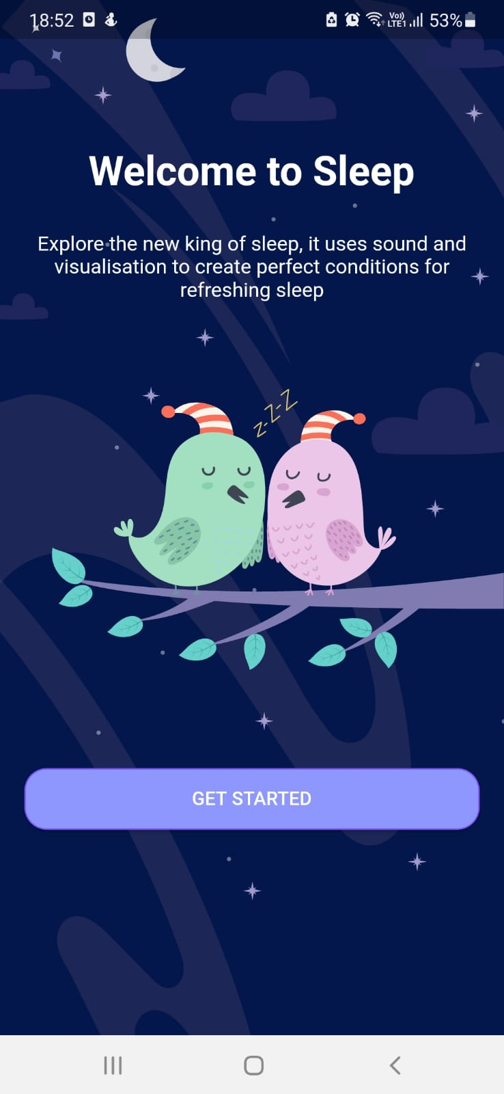

#### Fig 7.1 Home Page

### 7.2 Sleep stories page (where stories are available)

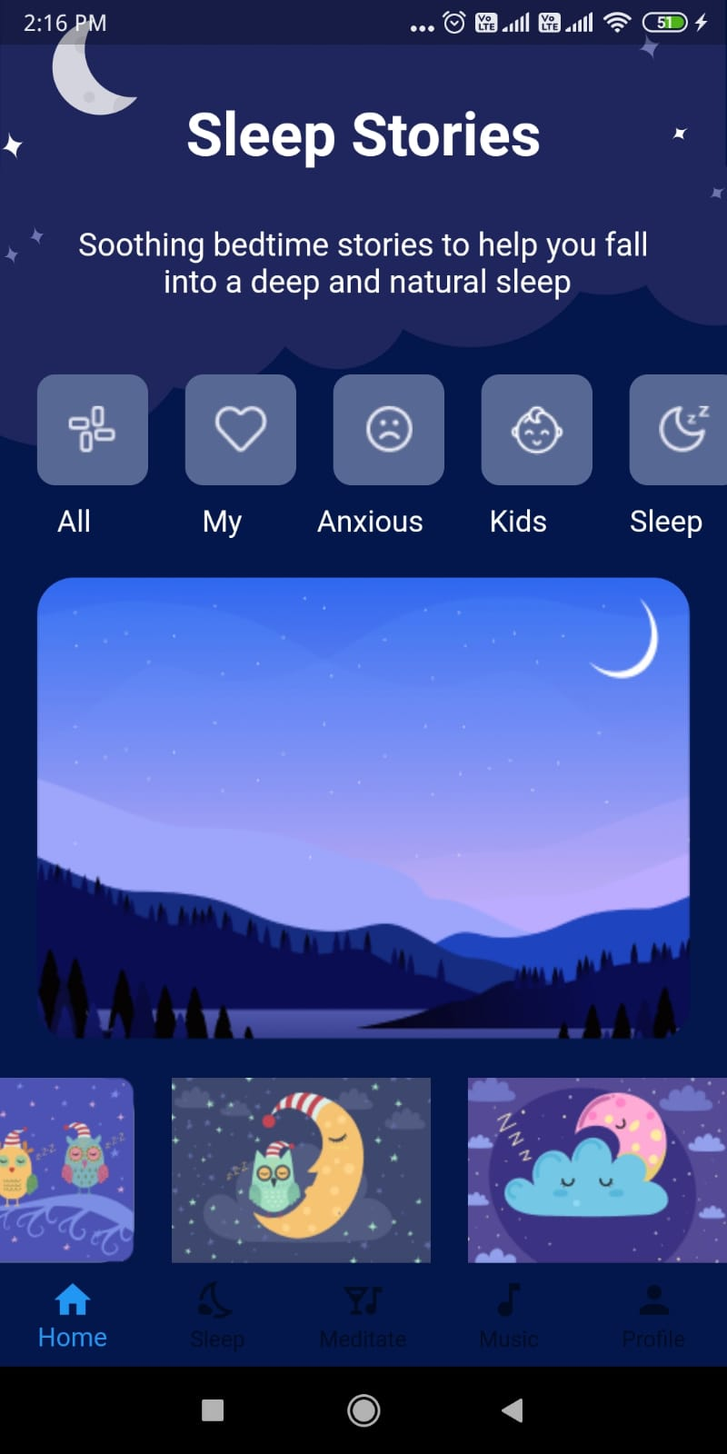

#### Fig 7.2 Display Sleep stories page

3*7*

Internship Project Bed Time Stories App

### 7.3 Story of a sweet Sleep 7.4 Story of a Night Island

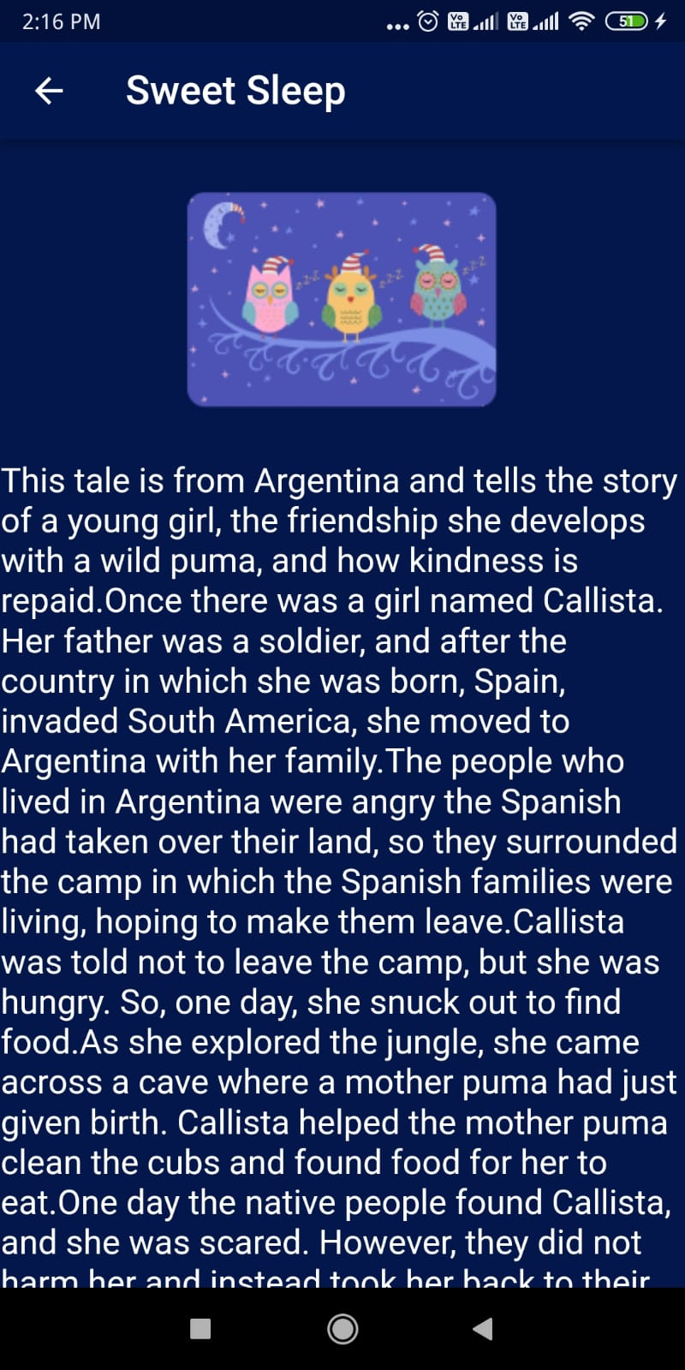 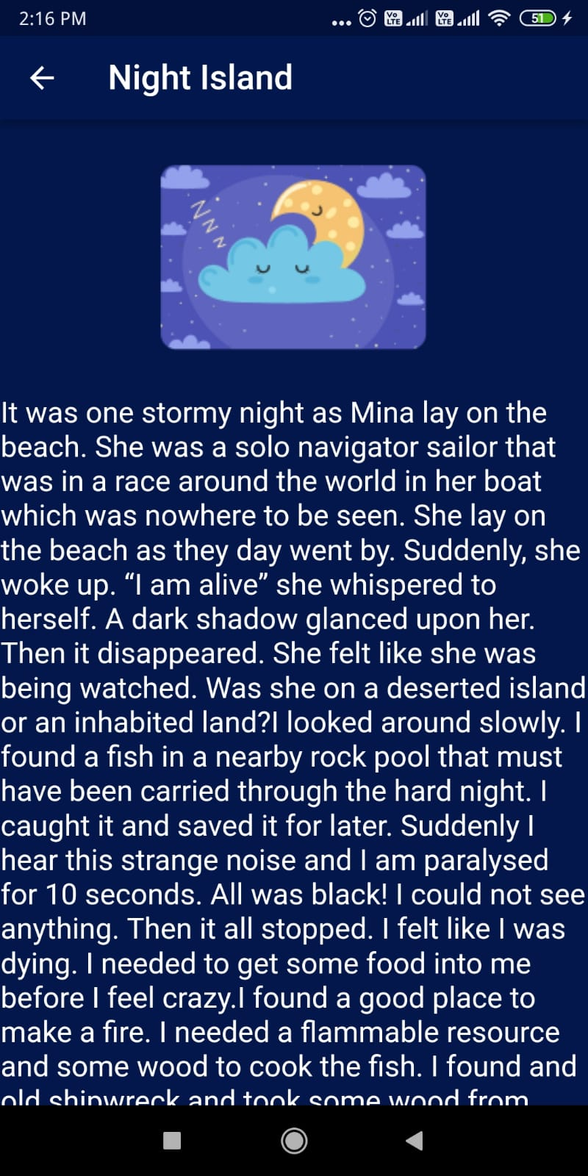

Fig 7.3 Stories

**Chapter 8**

## CONCLUSION AND FUTURE WORK

### 8.1 Conclusion

* This application is beneficial for the users who want to manage all their sleep at a single place.
* People can read stories that lets them sleep.
* Stories are based on a particular theme.

### 8.2 Future work

* We can add music to a particular story. This enables the person to sleep with ease.

* The contents for different themes can be categorised and added.
* We can also monitor sleep schedules by setting the time of sleep.

**Chapter 9**

## REFERENCES

* https://flutter.dev/
* https://developers.google.com/learn/pathways/intro-to-flutter
* Beginning Flutter: A Hands On Guide to App Development by Marco L Napoli
* https://stackoverflow.com/
* https:/[/www.geeksforgeeks.org/](http://www.geeksforgeeks.org/)